Background
From detection to interpretation of epistasis in Genome Wide Association Studies.
Thibault Latrille
Master BioSciences, Département de Biologie, Ecole Normale Supérieure de Lyon.
Institut des Science de l'Evolution de Montpellier (ISEM).
2013-12
Keywords : epistasis, gene interactions, Genome Wide Association Study, high-order interactions.
In the search for association between phenotype and genotype, interaction between, loci also known as epistasis, is on the highlight. Indeed, biologist expect that by taking into account epistasis, that is to say by embracing the complexity of living organisms, association studies will outperform their current achievements. Methods to detect epistasis stem from a vast array of discipline and challenge the most sophisticated algorithms. I provide here a critical survey of the methods and models able to detect and dive into these interactions between loci, in the case of Genome Wide Association Studies (GWAS). I also discuss the visualization tools available for interpreting high-order epistasis. In the light of currents achievement, I intend to establish a more effective, insightful and complete framework for analysis of epistasis in GWAS.
Finding the relationship between genetic polymorphisms and the phenotypic differences observed between individuals is of fundamental biological interest. To this aim, different framework were developed, specifically adapted to certain dataset such as linkage studies adapted to pedigrees, or Quantitative Trait Locus mapping developed for back-cross populations.
In this paper, I am investigating a different kind of studies, Genome Wide Association Studies (GWAS). GWAS score many Single Nucleotide Polymorphisms (SNPs) at once from a population of unrelated individuals, and measure their association with a phenotype with the presumption that some markers are in Linkage Disequilibrium with causative SNPs. Those studies rely on the availability of cheap and fast methods of genotyping, as such GWAS fully leverage the arrival of high-throughput genotyping and moreover take advantage of the increasing computing power available. In these studies the phenotype of the individuals can be a binary value e.g. Case/Control, or can be a continuous trait e.g. protein concentration.
Computationally, each variant is tested individually for association with the phenotype. This is based on the assumption that each locus affect independently the phenotype, i.e. there is no epistasis. In the case of a quantitative trait, this assumption of independence between loci is translated to additivity of the phenotype, i.e. the whole is equal to the sum of the parts. So far, GWAS have successfully identified association between disease risks and point-wise mutations across the genome [1]. However, the interaction between loci, i.e. epistasis, has often been cited as a reason for a lack of success of these studies [2] [3]. The term epistasis was coined by Bateson (1902) [4] in the light of distorted Mendelian ratio and was later on used in a statistical context as a departure from linearity by Fisher (1918) [5]. The subsequent borrowing of the concept from other fields lead to semanticdisagreements and issues confusing one interested by this subject. For example, the definition of epistasis is different in genetic and in the field of evolutionary biology[6]. The term epistasis has different yet close meaning and is sometime confounded with interaction, where interaction also has different meaning that are closely related to each others. Moreover, there are different type of epistasis: such as sign, weighted, additive or multiplicative epistasis. This semantic issue is discussed in Wang et al (2010) [7]. In the following discussion, by using the term interaction or equivalently epistasis, I will refer to statistical interaction measured on an additive scale, i.e. the combined effect of the factors is higher or less than the addition of the individual main effects. It is worth noticing that all the biological processes are treated as a black box. Indeed, physical interaction can occur at any stage, between any functional sequences/molecules. Although DNA-DNA interactions do exist, it is mostly the interactions between gene products that alter the final phenotypes, such as protein-protein, protein-DNA and protein-RNA interactions, each providing a new point of entry into understanding the complex physico-chemical gene-gene interaction system.
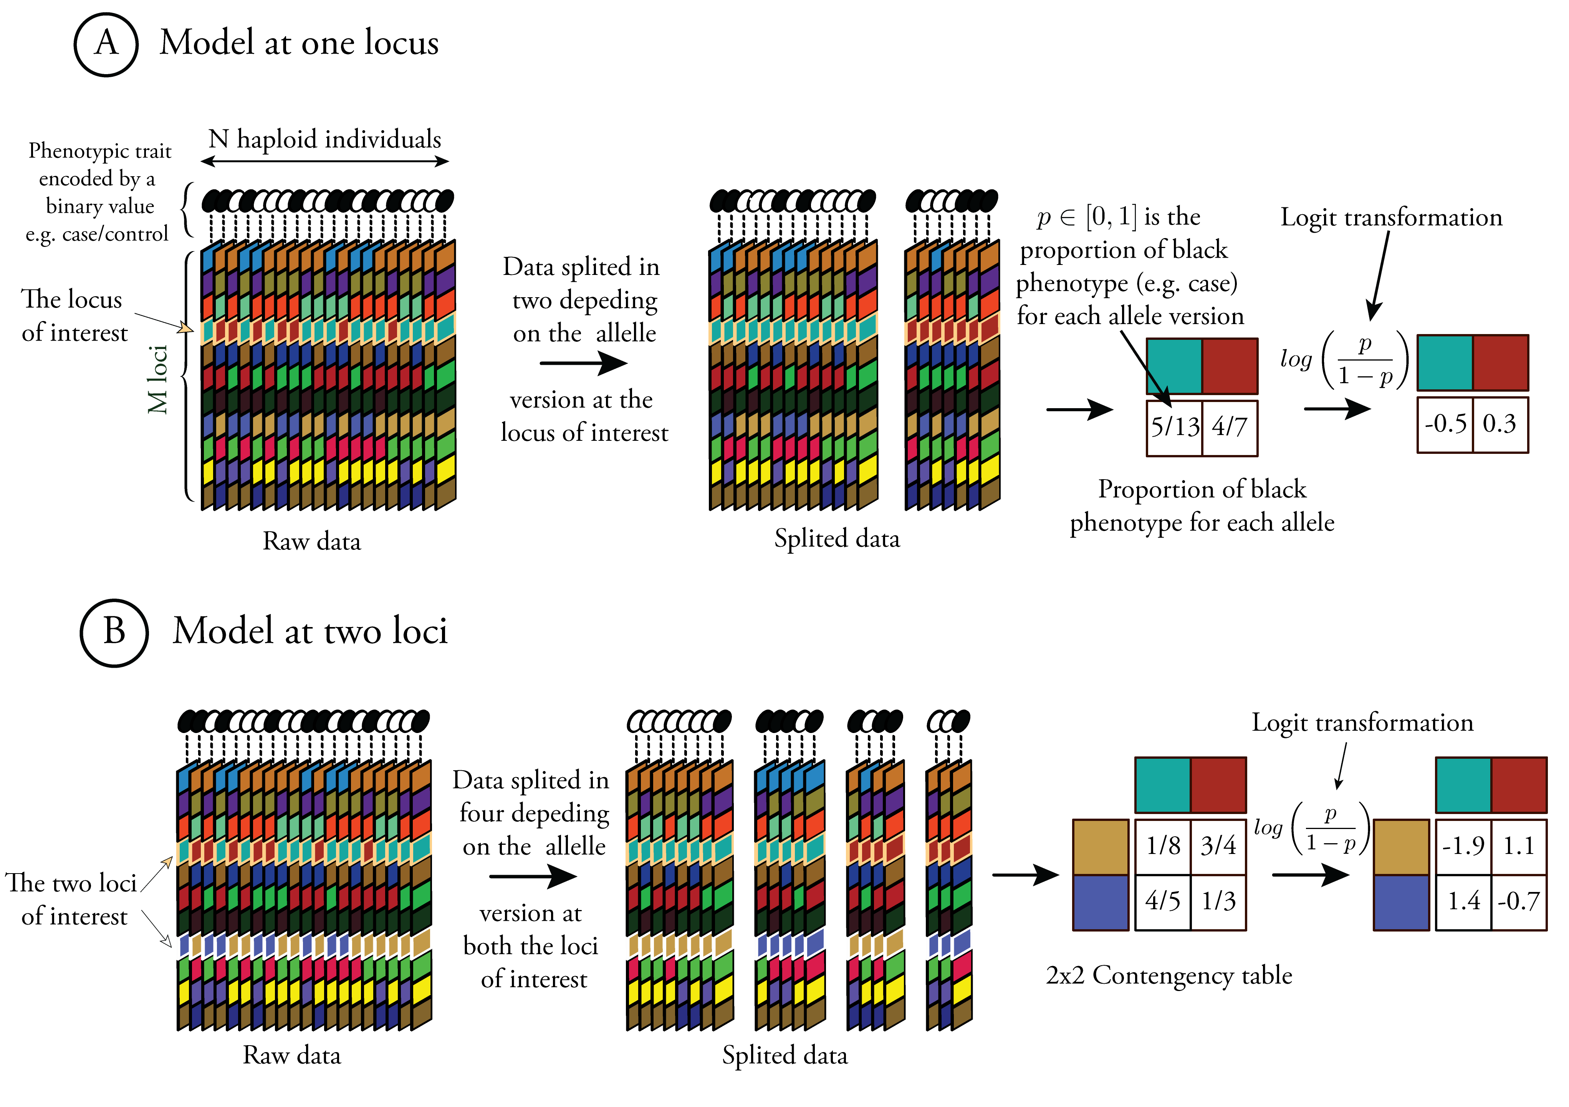
Figure 1. Hypothetical examples for main effect and pairwise epistasis.
Each column is an individual, comprised of a binary phenotypic trait (circle) and of genotypic data at m loci (square). Phenotypes are encoded by either black or white colors. Each locus has its own two colors representing the two possible alleles. Panel (A) represents the main effect of one locus (pink frame). The logit transformation allows to test departure from linearity instead of multiplicativity. Panel (B) represent the effect of interaction between two loci (pink and white frames). The contingency table allows a chi-squared test with exact p-value under certain assumptions.
For the sake of clarity, haploid individuals are represented but extension to diploid is straightforward. Instead of two colors per locus, one would encode the genotype by three colors, two for homozygous and one for heterozygous markers. The 2x2 contingency table in (B) would become a 3x3 table for diploids.
Box 1. Definitions.
Linkage disequilibrium: The non-random association of alleles within gametes, when the alleles involved are in linked loci. [7]
Penetrance: The probability of displaying a particular phenotype (for example, succumbing to a disease) given that one has a specific genotype. [1]
Machine Learning: The ability of a program to learn from experience, that is, to modify its execution on the basis of newly acquired information. A major focus of machine-learning research is to automatically produce models (rules and patterns) from data. [1]
Cross validation: This approach involves partitioning a data set into smaller subset, performing an analysis in one subset and using the other subset to measure or validate how well the analysis has performed. To reduce variability, multiple rounds of cross-validation are often performed using different partitions of the data and the validation results are averaged over the round. [1]

Formal definition of pairwise epistasis
For haploid individuals, pairwise epistasis is defined unambiguously [8]. Let us consider two loci with two variant each. For each locus the variant with the lowest phenotypic value is denoted by 0, the other variant by 1. The genotype space is thus G={01}²={00, 01, 10, 11}, forming four genotypes. Let us denote their respective related phenotype by ω₀₀, ω₀₁, ω₁₀ and ω₁₁. In the absence of epistasis, one would have:
ω₀₀+ω₁₁-ω₀₁-ω₁₀=0
In the case of positive epistasis, also called synergistic interaction, one would have:
ω₀₀+ω₁₁-ω₀₁-ω₁₀>0
Reciprocally, in the a case of negative epistasis, also called antagonist interactions, one would have:
ω₀₀+ω₁₁-ω₀₁-ω₁₀<0
In the case of diploid individuals, the genotype space for pairwise epistasis is composed of eight genotypes. Thus, for a general model, each locus has a parameter for dominance effect, and there is three more distinct pairwise epistasis; one between dominance effect and two due to epistasis between dominance and additive effect for both loci [9]. Formal definition to more than two loci is challenging and this issue will be discussed later on this paper.

Inherent challenges of GWAS for detecting pairwise epistasis
When seeking for interactions between loci, many challenges arise, while some can be tackled with relative ease, solving some others seems far-fetched. One of them is the difference in the phenotypes data, as seen previously. Indeed, dealing with continuous or binary trait is fundamentally different. Fortunately, binary trait can be converted to real valued data by computing the proportion of one type over the sum for one particular genotype. For case-control studies, this means calculating the penetrance of the disease for a certain genotype by evaluating the proportion of case over the number of individuals falling both in case and control groups [7]. Using the logit function, multiplicative effects on penetrance become additive effect on the transformed value, thus is departure from linearity is similar to departure from multiplicativity of a rare disease [7]. Refer to figure 1 for an example of these steps, for both main effect and pairwise epistasis. This transformation means that for each genotype, one only have access to one real value of the phenotype. While if the phenotypes where originally real valued, one would have access to estimates of the mean and the variance, provided there is more than one individual of this genotype, as such the dataset are still different. Dealing with binary traits has also it's own advantage. Indeed, a lots of methods were developed specifically for binary traits, in such studies the dataset is divided in two (case and control), and one seek to find genotype differences between the two dataset as indicator of association.
Table 1. Example of methods for extracting epistasis, their weaknesses and strengths.
Name | Trait | Detection principle | Search method | Pairwise/  Higher-order | Advantage(s) | Drawback(s)
BOOST [21] | Binary trait | Contingency table | Exhaustive | Pairwise | Fast and exhaustive search. | Limited to pairwise epistasis. Based on contingency table.
Tree based Epistasis Association Mapping (TEAM) [16] | Binary trait | Permutation test | Exhaustive | Pairwise | Exact testing, more powerful than Bonferonni correction. | Limited to pairwise epistasis. Not scalable to millions of SNPs
Logistic Regression with Interaction Term (LRIT) [18] | Binary trait | Logistic regression | Exhaustive | Pairwise | Epistasis is treated as departure from linearity. | Limited to pairwise epistasis.
Full Interaction Model (FIM) [12] | Binary trait | Logistic regression | Heuristic | Higher-order | Epistasis is treated as departure from linearity. | Miss several markers.
General model [9] | Binary trait | Chi-square | Exhaustive | Higher-order | Epistasis is treated as departure from linearity. | Not scalable.
EpiMODE (generalization of BEAM) [30] | Binary trait | Bayesian model | Stochastic | Higher-order | Separate the loci into independent subsets. Detect interactions with weak marginal effects. | No meaningful interpretation.
SNP Harvester (SH) [41] | Binary trait | Contingency table | Heuristic | Higher-order | Detect interactions with weak marginal effects. | Based on contingency table.
Tuned & Spatially Uniform ReliefF (TURF [25] a SURF [26]) | Binary trait | Nearest neighbor algorithm | Heuristic | Higher-order | Very fast and scalable filter. Detect interactions with weak marginal effects. | No statistical testing.
Information Gain (IG) [40] [39] | Binary trait | Mutual Information | Exhaustive | Higher-order | Useful to draw epistasis network, can compare epistasis of different order. | Rely on permutation testing. Exhaustive search, not scalable.
Random forest (RF) [31] | Binary trait | Prediction accuracy | Stochastic | Higher-order | Highly scalable. Detect interactions with weak marginal effects. | Rely on cross-validation for statistical testing.
Ant Colony Optimization (ACO) [23] | Binary trait | Contingency table | Heuristic (swarm intelligence) | Higher-order | The heuristic search, based on swarm intelligence. Detect interactions with weak marginal effects. | Based on contingency table.
Bayesian model selection [15] | Quantitative trait | Bayesian model | Exhaustive | Higher-order | For quantitative traits. Epistasis is treated as departure from linearity. | Exhaustive search, not scalable. Limited to pairwise epistasis.
ANOVA [29] | Quantitative trait | ANOVA test | Exhaustive | Higher-order | For quantitative traits. Epistasis is treated as departure from linearity. | Exhaustive search, not scalable.
Generalized multifactor dimensionality reduction (GMDR) [30] | Binary or quantitative trait | Prediction accuracy | Stochastic | Higher-order | Efficient for high-order epistasis. Deals with both quantitative and binary traits. | Rely on cross validation for statistical testing.
Neural networks [38] | Binary or quantitative trait | Prediction accuracy | Stochastic | Higher-order | Highly scalable. Deals with both quantitative and binary traits. | Rely on cross-validation for statistical testing.

When one wants to fit a model for epistasis, which is often the case with quantitative traits since it is seductive to fit a linear model [10], it is likely that the models will be over-parametrized. Indeed, one have to deal with many more markers than individuals, thus leading to over-parametrized models were statistical power is modest, and statistical tests do not provide meaningful results. One must reduce virtually this outbalances to get relevant results. One approach to overcome this over-parametrization problem is to shrink none relevant parameters to 0. This can be done by filtering out none relevant parameters of the models and compute the model without this parameters, these methods use a stepwise iteration [11] [12]. Other methods from various discipline inherently shrink those none relevant parameters to 0, such as penalized likelihood [13], lasso regression [14] or Bayesian methods [15]. Non-parametric testing are available for both quantitative and binary traits (see table 1), but they do not solve this issue since multiple testing also lead to modest statistical power.
Implementing a statistical test is not straightforward in GWAS, even if a statistical test for each pair of loci is provided. Indeed Bonferroni correction for multiple test apply only if test are independent, which is obviously not the case. Permutation testing is theoretically possible, such as in the software TEAM [16] but is computationally intractable for a dataset of millions of SNPs. A pragmatic approach to the multiple testing issue is to use a stringent significance threshold coupled with replication in an independent data set to avoid generating large numbers of false positives. As one might expect, each method as a different sensibility (avoid both false positive) and specificity (avoid false negative), and more particularly this performance is context dependent. That is to say the methods will demonstrate various strengths and weaknesses depending on the underlying factors, such as penetrance, minor allele frequency, main effects, and linkage disequilibrium. For a detailed comparison of the performance of most methods, refer to Shang et al (2011) [17], Chen et al (2011) [18] and Motsinger-Reif et al (2008) [19]. In this perspective, simulated data are of prominent help and allow one to accurately analyze performance of a wide range of methods under different assumptions and models. To this aim Yang and Gu (2013) developed simGWA [20], a general framework to achieve rapid whole-genome simulation with accurate modeling of complex interactions.
Apart from over-parametrization and statistical testing, crawling through GWAS data is computationally intensive. Indeed, with data from third generation sequencer, one might handle millions of SNP, where exhaustive search of pairwise epistasis is thus computationally prohibitive. The first remedy was to develop efficient algorithms. For example by minimizing the number of operation in the CPU (Central Processing Unit) by using Boolean representation of the data in BOOST [21], or by altering the data structure for memory access improvements [22], or even by leveraging the computing power of the GPU (graphics processing unit), as in the software Epiblaster [23]. An other solutions is not to compute all combinations, by filtering out loci with no main effects. Moreover, one can rely on stochastic search, or heuristic search to grab meaningful marker without computing all possible combinations, refer to table for such methods. So far, genotyping capabilities increases faster than computing capabilities, thus this issue is overgrowing.
Detecting pairwise epistasis is challenging, and unfortunately increasing the number of marker is not straightforward and poses theoretical problems. This issue is treated in the subsequent part of this paper.

Models for High-order epistasis
Many methods described in table were proven convincing to detect pairwise epistasis [1] [18] [17]. Thus, gene interactions among multiple loci are usually reduced to two-way interactions, while interactions are expected to be more complex [24]. Refinement to three-way or more has been proposed for case-control studies [9] using only chi-squared test, but also for quantitative traits studies. However these methods still don't grasp the full complexity of interactions and/or their interpretation is not explicit [8]. There is trade of between an accurate and readily interpretable model [9].
Moreover, in GWAS, the computational task is even more prohibitive and the power of test decreases dramatically due to the “curse of dimensionality”. Indeed the volume of the high-dimensional space increases severely and the available data becomes sparse. This sparsity is a serious issue for any method that seeks statistical significance. When one increases the number of loci in the model, far less individuals fall in each genotype, and at the same time the number of tests and therefore the amount of time needed to perform the analysis increases exponentially.
In order to reduce the computational task, as for pairwise epistasis, stepwise procedures are common, in which an exhaustive search of all higher-order interactions are carried out on a filtered subset of loci that pass some significance threshold. The obvious drawback is that this procedure would not detect interactions that genuinely occur in the absence of lower-order epistasis or main effect. Heuristic or stochastic searches are much preferred since the inherently take into account this filtering out depending on previous outcomes. One such efficient and fast methods based on a heuristic search to discard markers are Tuned ReliefF [25] or Spatially Uniform ReliefF (SURF) [26], based on neighborhood between genotypes to find interacting loci. An other efficient heuristic method is evaporative cooling[27] based on ReliefF and mutual information to evaporate (i.e. remove) noise features, leaving behind a subset of attributes that contain DNA sequence variations associated with a given phenotype.
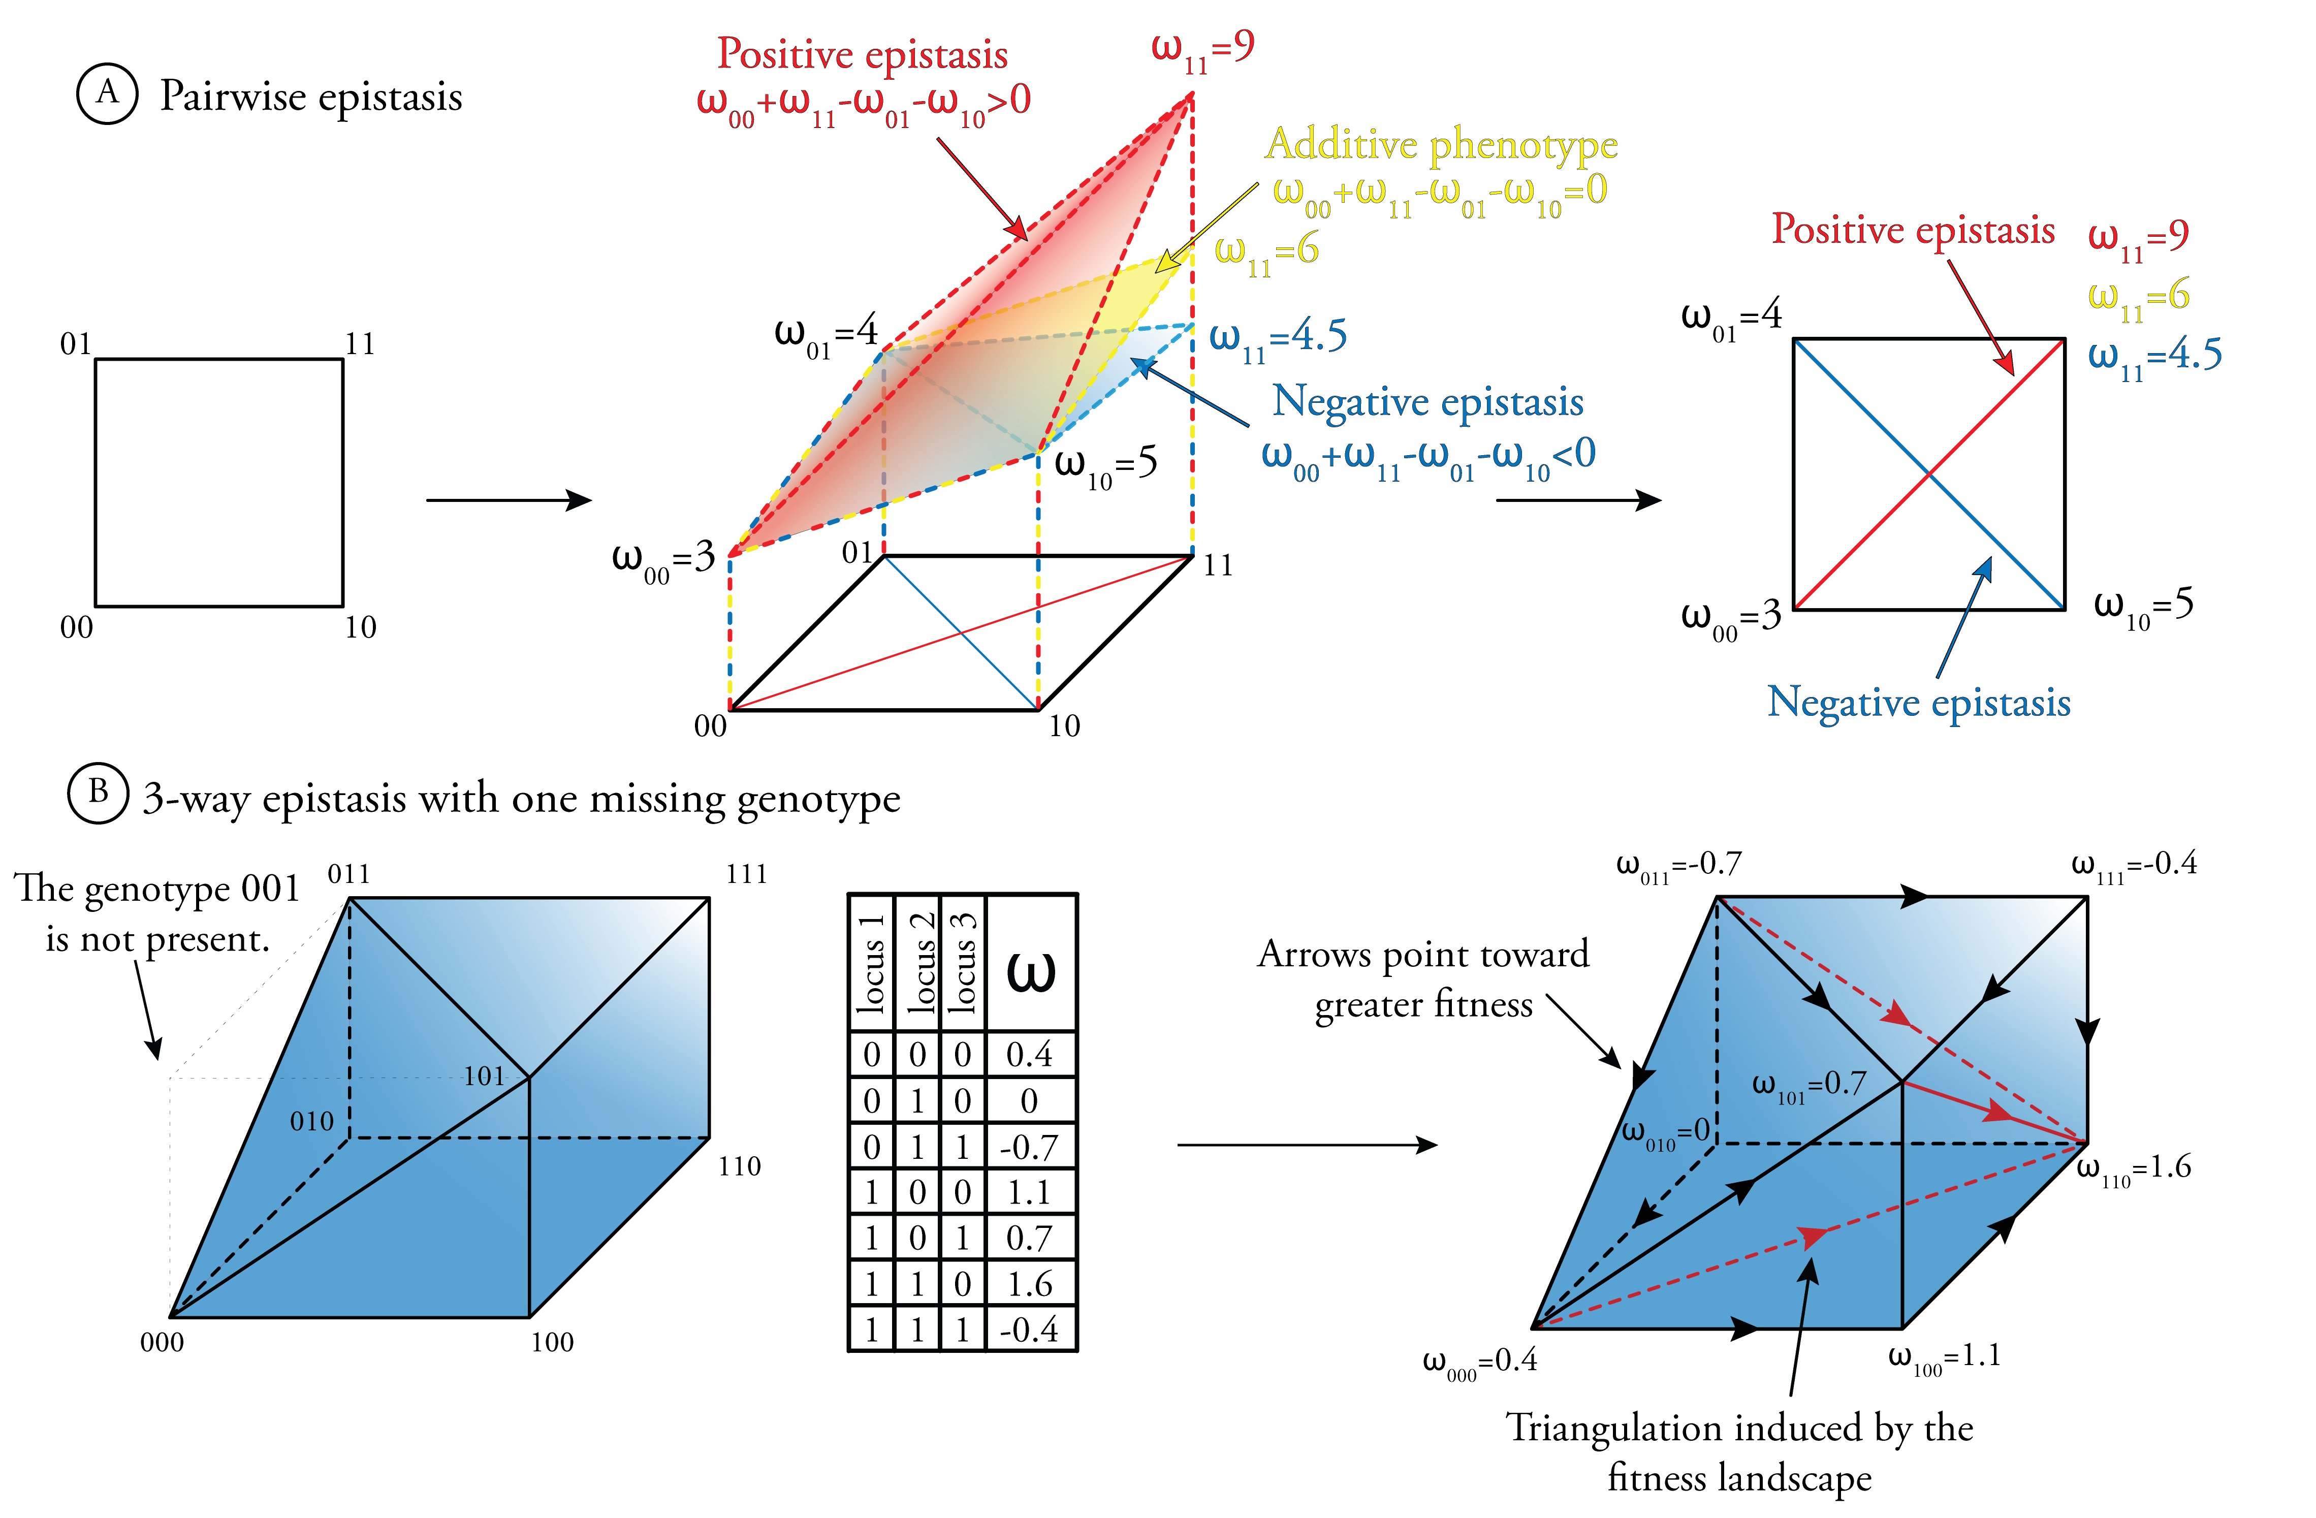
Figure 2. Relationship between the shape of the fitness landscape and epistasis.
On panel A, the relation between the triangulation of the square and pairwise epistasis. For each locus the variant with the lowest phenotypic value is denoted by 0, the other variant by 1. The genotype space is thus G={01}²={00,01,10,11}, forming four genotypes. Thus, the 2-dimensional genotope corresponding to two biallelic loci is a square. Let us denote their respective related phenotype by ω₀₀, ω₀₁, ω₁₀ and ω₁₁. For various value of ω₁₁, the epistasis is either null (in yellow), positive (in red) or negative (in blue). The geometric regular triangulation [35] of this shape lead to two distinct triangulation of the genotope. Depending on the sign of epistasis. On panel B, an hypothetical genotope in 3 dimensions (3 loci). The genotype space is G={000,010,011,100,101,110,111}, were the genotype 001 is missing. Let us assume that we have access to the fitness of each genotype (the table). This is a sufficient to compute the triangulation [35] of the corresponding genotope. The red lines represent this triangulation. Arrows point toward greater phenotypes. See figure 3 for an hypothetical dataset leading to this triangulation of genotope. Biologically speaking, the triangulations represent the fastest path to increase fitness, and genotype on different triangle (or tetrahedral) would benefit from recombining.
To deal with the issue of sparsity, machine-learning algorithms come in help, indeed this type of methods are specifically design to deal with high-dimensional data. One such astute procedure that received much attention in the case of epistasis is Multifactor Dimensionality Reduction (MDR) [28] [29]. One can use MDR analysis in case-control studies or for quantitative traits with Generalized-MDR [30]. It is a nonparametric method in that no parameters are estimated, and is free of any assumed genetic model. MDR pools multi-locus genotypes or environmental factors into high-risk and low-risk groups, effectively reducing the dimensionality from M (the number of loci) dimensions to one dimension. However, this procedure does not tell how the loci interact with each others. Random Forest [31] [32] is a very ingenious way to find potentially epistatic loci, for case/control studies. Tree are drawn from a random subset of the population of individuals, and only a random subset of markers are taken into account. The random forest is grown iteratively and the beauty is that epistasis can be detect by using trees grown on a different set of markers. The performance of the methods is highly dependent on the sampling parameters, and one should be familiar to the method to get relevant results.
All the methods described above are meant to improve the power of statistical tests in order to find loci showing a significant epistasis. While some methods aim to provide a visual tool to analyze cluster of interacting loci, such as ViSEN [33], they scarcely ever focus on the relevance and biological interpretation of high-order epistasis. All the machine-learning algorithms perform well at finding loci to interact, but usually are not relevant to biologist since the interpretation are deprived of biological meanings. Thus the real challenge remains how to justify and interpret the statistical interaction models and integrate the results with biological mechanisms.

Theoretical developments from evolutionary biology
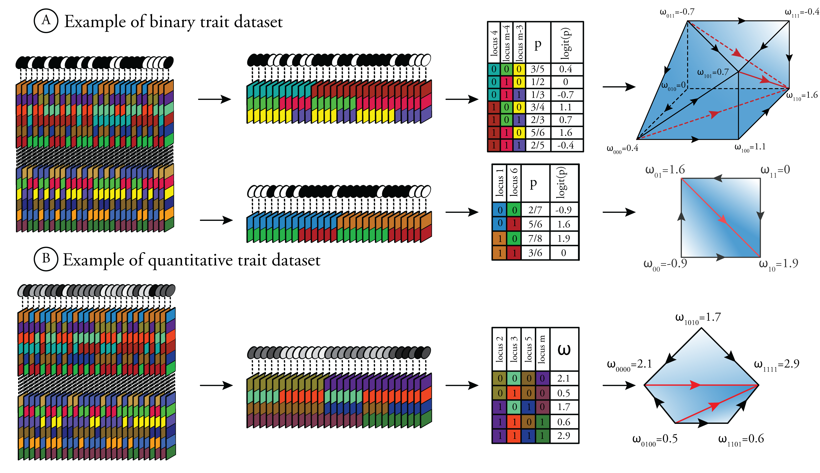
Figure 3. Two hypothetical examples of analysis of GWAS data, from detection of epistasis to visualization and interpretation.
On panel A, the phenotypes are binary (either black or white). The first step extracts two distinct subsets of loci that show signs of epistasis. Both subsets are analyzed, the penetrance (p) is estimated for each genotype as the proportion of black phenotypes. This penetrance is transformed using the logit function such that multiplicative effects become additive. The triangulation of the genotope [8] is computed and displayed as well as the arrows pointing toward greater penetrance. On panel B, the traits are quantitative (represented in shades of grey). The first step extracts one subset of loci that shows signs of epistasis. For each genotype, the mean phenotype is computed (ω). The genotope is of dimension four (the number of loci) and is made of five vertices (genotypes). A principal component analysis is computed as in Huggins et al (2007) [36] to project the genotope in two dimensions. The triangulation is computed on this projected genotope.
Simultaneously to these development for detecting epistasis, evolutionary geneticists put a lot of effort to describe epistasis at multiple loci theoretically. Indeed, epistasis plays a role in some theoretical developments such as the evolution of recombination, reproductive isolation, canalization and adaptation [24] [34]. Their regards to epistasis is quite different. They focused on multidimensional function mapping genotypes to a phenotype, such functions are called phenotypic landscape. Where the genotype can be of high dimension, and is not restricted to two or three dimensions (loci). One such well known landscape is the fitness landscape, mapping the information contained in the DNA to the ability to both survive and reproduce. Understanding this landscape is of primary importance for evolutionary biologists. Evolutionary biologists developed mathematical tools to represent this mapping.
One such tool, pioneered by Beerenwinkel et al (2007) [8] is purely geometrical. They proposed a geometric theory to assess for any order interaction. A central concept to their theory is the genotope, which is the convex hull of all possible allele frequencies in populations. The regular triangulations [35] of the genotope correspond to different shapes of fitness landscapes and reveal all the gene interactions (see figure 2). Biologically speaking, the triangulations represent the fastest path to increase fitness, and genotype on different triangle (or tetrahedral) would benefit from recombining. While their theory was developed in an evolutionary perspective using fitness as their phenotype, their framework is suited to any quantitative trait as well.
The main drawback is that when the dimension of the space (the order of interaction) is superior to three, the visual representation of the genotope in a euclidean space is impossible. Huggins et al (2007) [36] studied three different approaches for obtaining low dimensional (2 or 3) projections of the genotope; Principal Components Analysis, Archetypal analysis and projections onto few SNPs. Their approaches has not yet been fully leveraged and investigated. Other development based on the genotope were recently investigated, include fitness graphs by Crona et al (2012) [37]. In fitness graphs, nodes represent genotypes and arrows point toward more fit genotypes. Fitness graphs provide information that are not contained in the geometric classification of Beerenwinkel et al [8], and therefore provide complementary information to the genotope[37], fortuitously these two information can be superimpose (see figure 2).

Discussion
Although the contribution of epistatic interactions to quantitative genetic variation has been increasingly recognized by both evolutionary biologists and medical geneticists, their respective developments did not genuinely intertwined. On one hand, high order epistasis knowledge extracted for GWAS are not readily interpretable[1] while evolutionary biologists focused on geometric representation of epistasis [8]. On the other hand, Crona et al [37] argued that a qualitative perspective may help relating theory of fitness landscapes and empirical observations. Thus both theoretical evolutionary biology and association studies will greatly benefit from one another. But work has yet to be completed. To this aim I intend to provide a general framework, see an example in figure 3. This framework take has input a GWAS dataset, were the individual's phenotype is either binary or quantitative. Various methods will extract subsets of loci that display signs of epistasis. To this aim, the method used will depend on the dataset, the order of epistasis investigated, the computing power and time available, and so on. Once extracted, those subsets will be further investigated and the software will display the triangulation of the genotope associated (or the projection in a 2 or 3 dimensional space) as well as the statistical significance and other relevant computed information.
I urge for the development of a software suite that will provide a framework for any geneticist interested in interacting loci. This software suite must be upgradable, and more importantly updated as soon as theoretical or computational development would be available.

Acknowledgments
I thank F. Rousset and D. Galiana for their help and their advices concerning this review. A consecration to my laptop who coped my relentless bashing.

References and recommended reading
Papers of particular interest have been highlighted as:
of special interest
of outstanding interest

1. Cordell HJ: Detecting gene-gene interactions that underlie human diseases. Nat. Rev. Genet. 2009, 10:392–404. [doi: 10.1038/nrg2579]
Review of mainstream methods to detect epistasis.
2. Culverhouse R, Suarez BK, Lin J, Reich T: A perspective on epistasis: limits of models displaying no main effect. Am. J. Hum. Genet. 2002, 70:461–71. [doi: 10.1086/338759]
3. Moore JH: The ubiquitous nature of epistasis in determining susceptibility to common human diseases. Hum. Hered. 2003, 56:73–82.
4. Bateson W: Mendel’s principles of heredity. University Press; 1902.
5. Fisher RA: XV.—The Correlation between Relatives on the Supposition of Mendelian Inheritance. Trans. R. Soc. Edinb. 1919, 52:399–433.
6. Moore JH, Williams SM: Traversing the conceptual divide between biological and statistical epistasis: systems biology and a more modern synthesis. BioEssays News Rev. Mol. Cell. Dev. Biol. 2005, 27:637–46. [doi: 10.1002/bies.20236]
7. Wang X, Elston RC, Zhu X: The meaning of interaction. Hum. Hered. 2010, 70:269–77. [doi: 10.1159/000321967]
Clear and precise definition of epistasis.
8. Beerenwinkel N, Pachter L, Sturmfels B: Epistasis and shapes of fitness landscapes. [date unknown], [no volume].
Introduced the genotope and the triangulation of the fitness landscapes.
9. Wang Z, Liu T, Lin Z, Hegarty J, Koltun W a, Wu R: A general model for multilocus epistatic interactions in case-control studies. PloS One 2010, 5:e11384. [doi: 10.1371/journal.pone.0011384]
10. Carlo M: Mapping QTLs with epistatic effects and QTL × environment interactions by mixed linear model approaches. 1995, [no volume].
11. Hoh J, Wille a, Zee R, Cheng S, Reynolds R, Lindpaintner K, Ott J: Selecting SNPs in two-stage analysis of disease association data: a model-free approach. Ann. Hum. Genet. 2000, 64:413–7.
12. Marchini J, Donnelly P, Cardon LR: Genome-wide strategies for detecting multiple loci that influence complex diseases. Nat. Genet. 2005, 37:413–7. [doi: 10.1038/ng1537]
13. Zhang Y-M, Xu S: A penalized maximum likelihood method for estimating epistatic effects of QTL. Heredity 2005, 95:96–104. [doi: 10.1038/sj.hdy.6800702]
14. Wu TT, Chen YF, Hastie T, Sobel E, Lange K: Genome-wide association analysis by lasso penalized logistic regression. Bioinforma. Oxf. Engl. 2009, 25:714–21. [doi: 10.1093/bioinformatics/btp041]
15. Yi N, Yandell BS, Churchill G a, Allison DB, Eisen EJ, Pomp D: Bayesian model selection for genome-wide epistatic quantitative trait loci analysis. Genetics 2005, 170:1333–44. [doi: 10.1534/genetics.104.040386]
16. Zhang X, Huang S, Zou F, Wang W: TEAM: efficient two-locus epistasis tests in human genome-wide association study. Bioinforma. Oxf. Engl. 2010, 26:i217–27. [doi: 10.1093/bioinformatics/btq186]
17. Shang J, Zhang J, Sun Y, Liu D, Ye D, Yin Y: Performance analysis of novel methods for detecting epistasis. BMC Bioinformatics 2011, 12:475. [doi: 10.1186/1471-2105-12-475]
Review of the performance of various methods.
18. Chen L, Yu G, Langefeld CD, Miller DJ, Guy RT, Raghuram J, Yuan X, Herrington DM, Wang Y: Comparative analysis of methods for detecting interacting loci. BMC Genomics 2011, 12:344. [doi: 10.1186/1471-2164-12-344]
Review of the strengths and weaknesses of various methods.
19. Motsinger-Reif A a, Reif DM, Fanelli TJ, Ritchie MD: A comparison of analytical methods for genetic association studies. Genet. Epidemiol. 2008, 32:767–78. [doi: 10.1002/gepi.20345]
20. Yang W, Gu CC: A whole-genome simulator capable of modeling high-order epistasis for complex disease. Genet. Epidemiol. 2013, 37:686–94. [doi: 10.1002/gepi.21761]
21. Wan X, Yang C, Yang Q, Xue H, Fan X, Tang NLS, Yu W: BOOST: A fast approach to detecting gene-gene interactions in genome-wide case-control studies. Am. J. Hum. Genet. 2010, 87:325–40. [doi: 10.1016/j.ajhg.2010.07.021]
22. Lishout V, John JMM, Gusareva ES, Urrea V, Calle ML, Wehenkel L, Cleynen I, Th E: An efficient algorithm to perform multiple testing in epistasis screening Franc e a. 2013, [no volume].
23. Kam-Thong T, Czamara D, Tsuda K, Borgwardt K, Lewis CM, Erhardt-Lehmann A, Hemmer B, Rieckmann P, Daake M, Weber F, et al.: EPIBLASTER-fast exhaustive two-locus epistasis detection strategy using graphical processing units. Eur. J. Hum. Genet. EJHG 2011, 19:465–71. [doi: 10.1038/ejhg.2010.196]
24. Hansen TF: Why Epistasis Is Important for Selection and Adaptation. Evolution 2013, doi:10.1111/evo.12214. [doi: 10.1111/evo.12214]
25. Moore JH, White BC: Tuning ReliefF for genome-wide genetic analysis. In Evolutionary computation, machine learning and data mining in bioinformatics. Springer; 2007:166–175.
26. Greene CS, Penrod NM, Kiralis J, Moore JH: Spatially uniform relieff (SURF) for computationally-efficient filtering of gene-gene interactions. BioData Min. 2009, 2:5. [doi: 10.1186/1756-0381-2-5]
27. McKinney B a, Reif DM, White BC, Crowe JE, Moore JH: Evaporative cooling feature selection for genotypic data involving interactions. Bioinforma. Oxf. Engl. 2007, 23:2113–20. [doi: 10.1093/bioinformatics/btm317]
28. Moore JH: Computational analysis of gene-gene interactions using multifactor dimensionality reduction. Expert Rev. Mol. Diagn. 2004, 4:795–803. [doi: 10.1586/14737159.4.6.795]
A very astute method for detecting high-order epistasis.
29. Mahachie John JM, Van Lishout F, Gusareva ES, Van Steen K: A robustness study of parametric and non-parametric tests in model-based multifactor dimensionality reduction for epistasis detection. BioData Min. 2013, 6:9. [doi: 10.1186/1756-0381-6-9]
30. Lou X-Y, Chen G-B, Yan L, Ma JZ, Zhu J, Elston RC, Li MD: A generalized combinatorial approach for detecting gene-by-gene and gene-by-environment interactions with application to nicotine dependence. Am. J. Hum. Genet. 2007, 80:1125–37. [doi: 10.1086/518312]
31. Jiang R, Tang W, Wu X, Fu W: A random forest approach to the detection of epistatic interactions in case-control studies. BMC Bioinformatics 2009, 10 Suppl 1:S65. [doi: 10.1186/1471-2105-10-S1-S65]
32. Boulesteix A-L, Janitza S, Kruppa J, König IR: Overview of random forest methodology and practical guidance with emphasis on computational biology and bioinformatics. Wiley Interdiscip. Rev. Data Min. Knowl. Discov. 2012, 2:493–507. [doi: 10.1002/widm.1072]
33. Hu T, Chen Y, Kiralis JW, Moore JH: ViSEN: methodology and software for visualization of statistical epistasis networks. Genet. Epidemiol. 2013, 37:283–5. [doi: 10.1002/gepi.21718]
34. Weinreich DM, Lan Y, Wylie CS, Heckendorn RB: Should evolutionary geneticists worry about higher-order epistasis? [Internet]. Curr. Opin. Genet. Dev. 2013, doi:10.1016/j.gde.2013.10.007. [doi: 10.1016/j.gde.2013.10.007]
35. De Loera JA, Rambau J: Triangulations: Structures for algorithms and applications. Springer; 2010.
36. Huggins P, Pachter L, Sturmfels B: Toward the human genotope. Bull. Math. Biol. 2007, 69:2723–35. [doi: 10.1007/s11538-007-9244-7]
Introduced projection of the genotope in a low dimensional space.
37. Crona K, Greene D, Barlow M: The peaks and geometry of fitness landscapes. J. Theor. Biol. 2013, 317:1–10. [doi: 10.1016/j.jtbi.2012.09.028]
Introduced the fitness graph and discussed the paper of Beerenwinkel et al.
38. Turner SD, Dudek SM, Ritchie MD: Grammatical evolution of neural networks for discovering epistasis among quantitative trait loci. In Evolutionary Computation, Machine Learning and Data Mining in Bioinformatics. Springer; 2010:86–97.
39. Fan R, Zhong M, Wang S, Zhang Y, Andrew a, Karagas M, Chen H, Amos CI, Xiong M, Moore JH: Entropy-based information gain approaches to detect and to characterize gene-gene and gene-environment interactions/correlations of complex diseases. Genet. Epidemiol. 2011, 35:706–21. [doi: 10.1002/gepi.20621]
40. Anuncia\ccão O, Vinga S, Oliveira AL: Using information interaction to discover epistatic effects in complex diseases. PloS One 2013, 8:e76300. [doi: 10.1371/journal.pone.0076300]
41. Yang C, He Z, Wan X, Yang Q, Xue H, Yu W: SNPHarvester: a filtering-based approach for detecting epistatic interactions in genome-wide association studies. Bioinforma. Oxf. Engl. 2009, 25:504–11. [doi: 10.1093/bioinformatics/btn652]

